MOTORCADE/FLASHPARADE  National Open Competition  Preview:  Thursday 8th December 2011  6:00pm till late  Join us for a champagne reception and prize giving ceremony.  Bar + food + music  Exhibition continues:  Friday 9th – Sunday 18th December  Opening hours: Thursday – Sunday, 12-6pm | 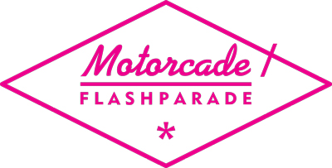  www.motorcadeflashparade.com  37 Philip Street, Bedminster, Bristol BS3 4EA

Motorcade/FlashParade’s first National Open Competition was selected by
Mandy Ure, S. Mark Gubb and Cathy Lomax.

Selected Artists

Rhiannon Adam  Zanne Andrea  Milo Brennan  Lindsey Bull  Julie Coltman  Martyn Cross  Gordon Dalton  Davies, Monaghan & Klein  Anne Deeming  Elizabeth Dismorr | Lauren Faulkes  Thomas Goddard  Alex Hardy  Denise Hickey  Daniel Just  Will Kendrick  Brendan Lancaster  Angela Lizon  Ian Robinson  Harriet White
3 winners will be announced in a prize giving ceremony at the preview on Thursday 8th December.

Prizes:
1st Prize - £300 and a solo show
2nd Prize – a solo show
3rd prize – £150 vouchers

Motorcade/FlashParade is a platform for emerging artists primarily based in Bristol and the South west, hosting an annual programme of contemporary exhibitions and other events. Initiated in 2009 it is fast evolving into an exciting test space for contemporary practice. We support and encourage the development of new work and fresh ideas. We host a range of activities to support arts practice and foster peer learning and participation from a wider audience. We are a test space, a laboratory, a launch pad and a stage.

